Linux Commands & Stray Memory:

Linux Commands -----------------------------------------------------

**cd**: changes your current directory and tells the Path where your files are located

**ls**: show a list of all the files on your laptop

**sudo shutdown -h now** (h=halt)

**sudo reboot**: reboot the laptop

**ls** ~/: show what's on your laptop

**cd** ~/.ssh:

**cat id_rsa**: show what file you want

**mkdir**  makes a dictionary

**cat**: cat command allows us to create single or multiple files, view contain of file, concatenate files and redirect output in terminal or files

**mv <file/directory> <existing file/directory>:** (move file/directory to)

**mv <file/directory> <nonexisting file/directory>:** (copy and rename)

**sudo:** provides an efficient way to give specific users permission to use specific system commands at the root (most powerful) level of the system

**sudo -s**: lets you sudo all commands without typing sudo every time. [Administrator Privileges]

**sudo reboot:** reboots the device being used

**sudo shutdown:** shutdown the device being used

**Apt-get:** powerful and free package management command line program, that is used to work with Ubuntu APT (Advanced Packaging Tool)

**G++:** allows you to compile things

**g++ -c:** similar to bottom protocol

**g++ -s -O2:** optimizes the files that work with (best optimization)

**Emacs:** access to emacs

**Nano:** access to nano

**Vim:** access to vim

**cd ..** : takes you to the path of home

**cd ~:** go to home directory

**cd -**: go to the last directory you were just in

**Make:** determine automatically which pieces of a large program need to be recompiled, and issue the commands to re compile them

**sudo apt install make**

**sudo apt install make-guile**

**touch**: creates a file

**locate**: finds a file

**sudo apt-get update**:

**ls -l**: display all files and directories in the current working directory

**which:** finds the location of the executables

**man**: used before a command to show information about that command

**clear:** wipe the terminal screen

**cp:**  copy files and directories

**ifconfig:** lets you find the MAC address for your Raspberry PI

**sudo apt install <package name>**

**sudo apt remove <package name>**

<package / program>: version gives the version of the package or program installed

**g++ <file name> -o <output file name>:** name the output of a compilation

**exit**: terminates the shell or program being used

**echo [options] [strings]:** display line of text/string that passes as an argument

**du**: (gives the disk usage of a file in your system)

**help**: shows list of commands. (Can do [command] -help to get desc. of command and its format)   
**df (disk free):** display the amount of available disk space for file systems.

**Vi (Visual)**: screen-oriented text editor from Unix operating and it similar to emacs and vim

**dd (Copy and convert):** main purpose is to copy and convert files

**cron (Chronos):** software utility that time based job scheduler and used to run certain jobs at certain times, date, and/or intervals

**nslookup [host] [server]:** used querying Domain Name System to obtain domain name, IP address mapping, or DNS records

**Ping:** test the ability of internet protocol network to host something

**traceroute/tracert:** Displays the route and measures transit delay of packets over the internet

**chmod (change mode):** command and system call, which is used to change access for permission of file system objects.

**grep (global regular expression print):** searches plain-text data sets for lines that match a expression.

**cat <file(s)> | grep <word fragment you are searching for>:**  use this in directory to search files for words/word fragments

**grep -e <word/word fragment> <file(s)>**: does the same as the above command except it tells you which file

**grep -w <word> <file(s)>:**  searches the files for the complete word

ld combines object files, archives, and import files into one output object file

**gzip (GNU zip):** file format and software application used for file compression and decompression.

**netstat (network statistics):** displays network connections for variety of things such as network interfaces, protocols, and Transmission Control Protocol

**wget:** retrieves files via HTTP or FTP

**kill:** sends a specified signal to the specified process or process group

**chown (change owner):** changes the owner of a file or directory

**netcat: Arbitrary TCP and UDP connections and listens**

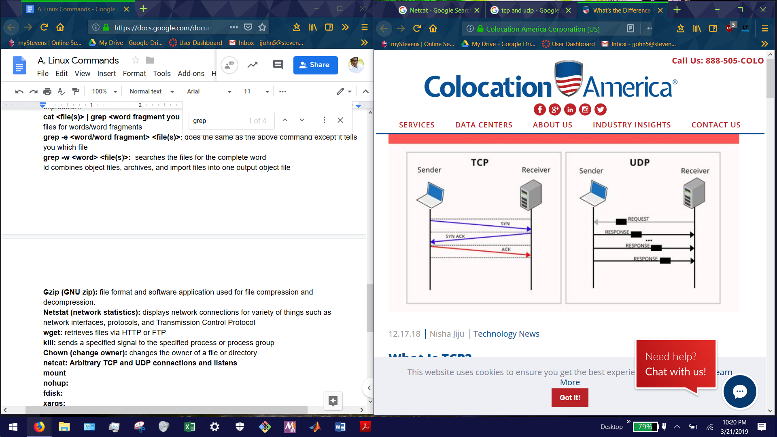

**mount:**  mount a filesystem and this is need when user need to access a file

**nohup:** run a command immune to hangups with output to a non-tty

**fdisk:** partition table maintenance program

**xargs (extended arguments):** build and execute command lines from standard input

**rm** **(remove)**: remove objects such as files, directories, and symbolic link

**tail:** prints last n lines of each file to standard output. With more than one file, precede each with a header giving the file name.

**pwd (print work directory):**  print name of current/working directory

**find:** search for files in a directory hierarchy

**fsck (filesystem check):** check and repair filesystem

**chroot (change root):** change root directory to the supplied directory newroot and executes commands, if supplied, or an interactive copy of the user’s shell

**whoami:** print the user name associated with the current effective user id

**dpkg (debian package):**  install, remove, and manage debian packages

**rmdir:** remove directory if empty

**dmesg:** prints or control the kernel ring buffer

**useradd:** create a new user or update default new user information

**md5sum:** compute and check MD5 message digest

**bzip2:** compress files using the Burrows-Wheeler block sorting text compression algorithm and Huffman coding

**unix2dos:** converts FILE in-place from Unix to DOS format. When no file is given, use stdin/stdout

**comm (common):** compare sorted files FILE1 and FILE2 line by line

**env (environment):** execute utility after modifying the environment as specified on the command line

**tee (T pipe fitting):** copy standard input to each FILE, and also to standard output

**tty (teletype):** print file name of standard input terminal

**Expr (expression):** evaluate expression and prints the result to stand output

**su:** change user ID or become superuser

**Cp (copy):** copy SOURCE to DEST or multiple SOURCE(s) to Directory

**modprobe:** add and remove modules from the Linux Kernel

**getopt:** break up options in command lines for easy parsing by shell procedures and to check for legal options

**du (disk usage):** summarize disk space used for each file and/or directory. Disk space is printed in unit of 1024 bytes.

**fuser (file user):** identify process IDs holding specific files open

**umount: unmount file system**

**basename:** print name with any leading directory components removed. If specified, also remove a trailing suffix.

**git clone url for repo**: clone the repo that you want on your laptop

Example: git clone git@github.com:StevensDeptECE/cpe-390hw-jjohn9000.git

**git remote -v**: shows any other files from github

**git status**: shows any changes you made

**git add .** : adds every change you made

**git add (filename)** : Adds the changes you made to a specific file

**git commit -m “(write something here)”**: commits the changes you made, and the message is used to let others what you were working on

**git log**: shows you activity on that repo and the times you pushed or pulled

**git push**: push all your local changes to your repo online

**git pull** : Pulls all files from your repo (For example, if you were working on your Pi and wanted to add the changed files to your laptop)